## **Digital Forensics Investigation Report: John Washer**

**Investigator:** Ethan Spade  
**Case File:** Washer.E01 Analysis  
**Date:** 11/16/25  
**Tools Used:** Autopsy, Registry Explorer, HashCalc, Hex Workshop, John the Ripper, Snip Tool

### **1. Executive Summary**

This report presents the results of a forensic examination of the disk image Washer.E01, attributed to user John Washer, with the primary objective of determining potential connections to the previously analyzed Mantooth system and identifying evidence of criminal or concealed digital activity. The investigation focused on system artifacts, user documents, communication records, browser activity, and encrypted or deleted files to reconstruct user behavior and assess intent. Analysis revealed active email usage, suspicious document handling, identity-related search activity, and the presence of encrypted files alongside artifacts directly referencing Wes Mantooth. Timeline reconstruction and registry evidence further indicate deliberate file access, data movement, and possible attempts at concealment shortly before system acquisition.

### **2. Scope of Investigation**

The objectives of this analysis were to:

* Identify the primary user(s) and related account activity.
* Correlate evidence linking ***John Washer*** to ***Wes Mantooth***.
* Discover potential password-protected or encrypted files and attempt decryption.
* Examine system logs, browser history, and communications for evidence of illegal activity.
* Identify, recover, and document deleted or hidden artifacts.
* Construct a timeline of significant user actions and digital events.
* Ensure all findings are supported by authenticated forensic data.

All data was examined using industry standard tools and validated with cryptographic hash verification to preserve evidentiary reliability.

### **3. Hash Verification**

**Evidence Item:** Washer.E01  
**MD5:** 147307d626aa2c090bd6abfe4a9a1909  
**Verification Result:** Match

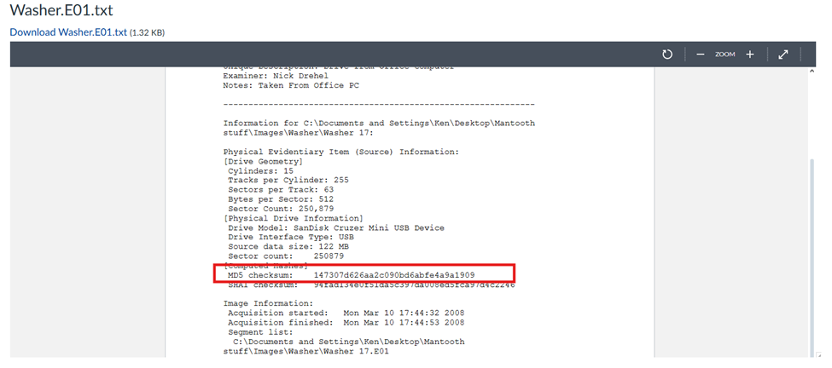

Figure 1 MD5 Hash from Washer.E01

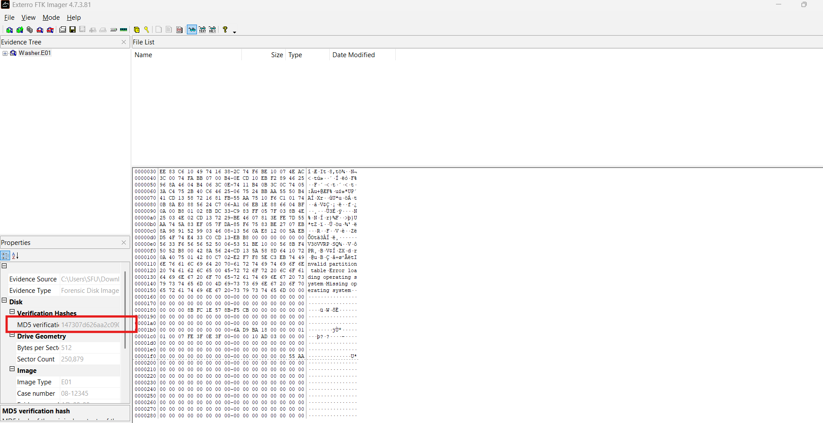

Figure 2 MD5 hash found on FTK Imager

### **4. Key Findings and Artifacts**

#### **1. Image Verification**

* Confirmed MD5 hash with Washer.E01.txt file: Yes

#### **2. System Information**

* Main Windows user account: Captain hook

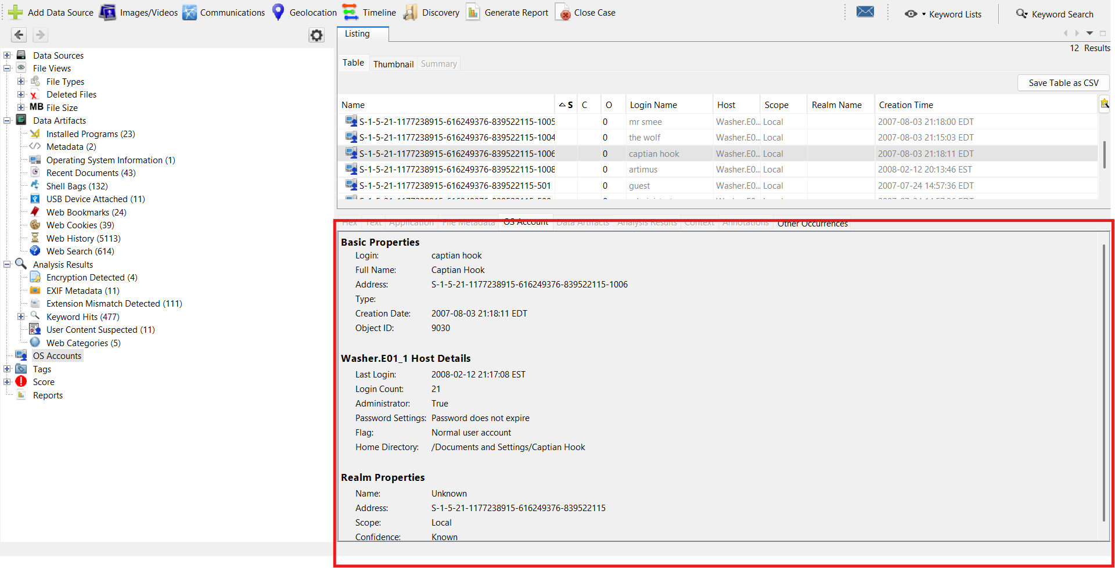

Figure 3 shows the main user account titled Captain Hook

* Operating System version: Microsoft Windows XP

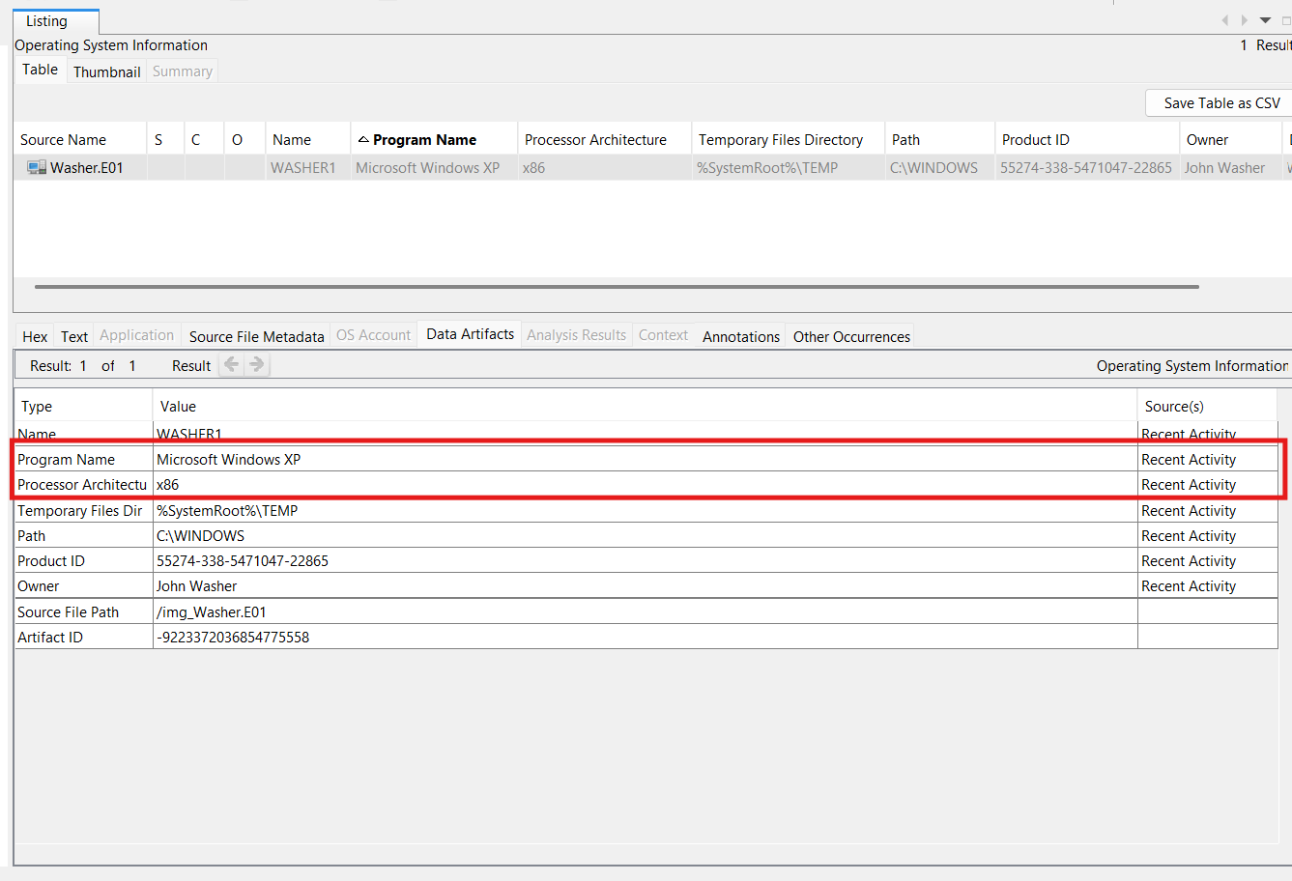

Figure 4 shows the OS used on this device

* Time zone setting: Amrica/ New York (EST)

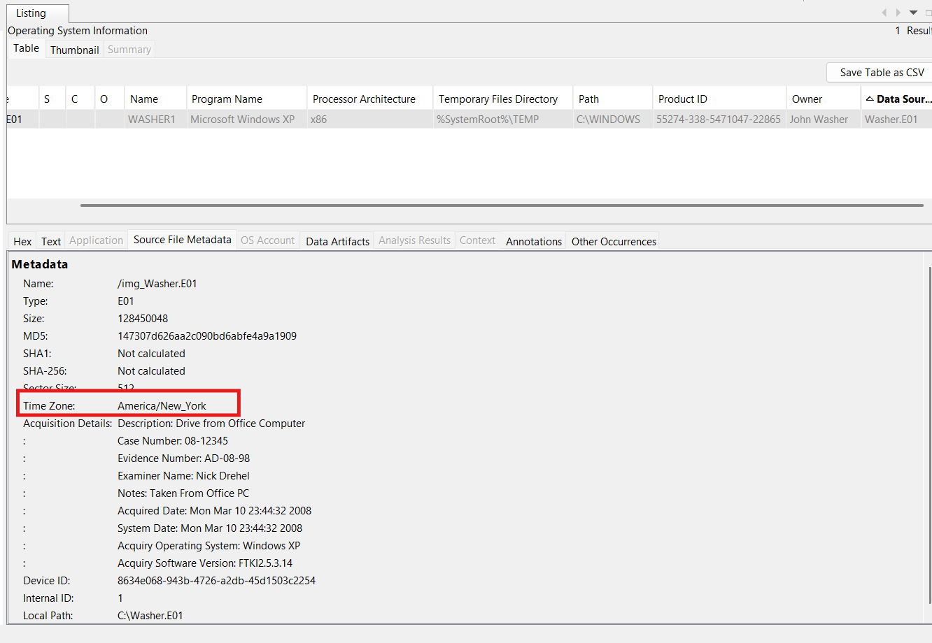

Figure 5 shows the time zone the device was in

* Last login time: 2008-02-12 21:17:08 EST

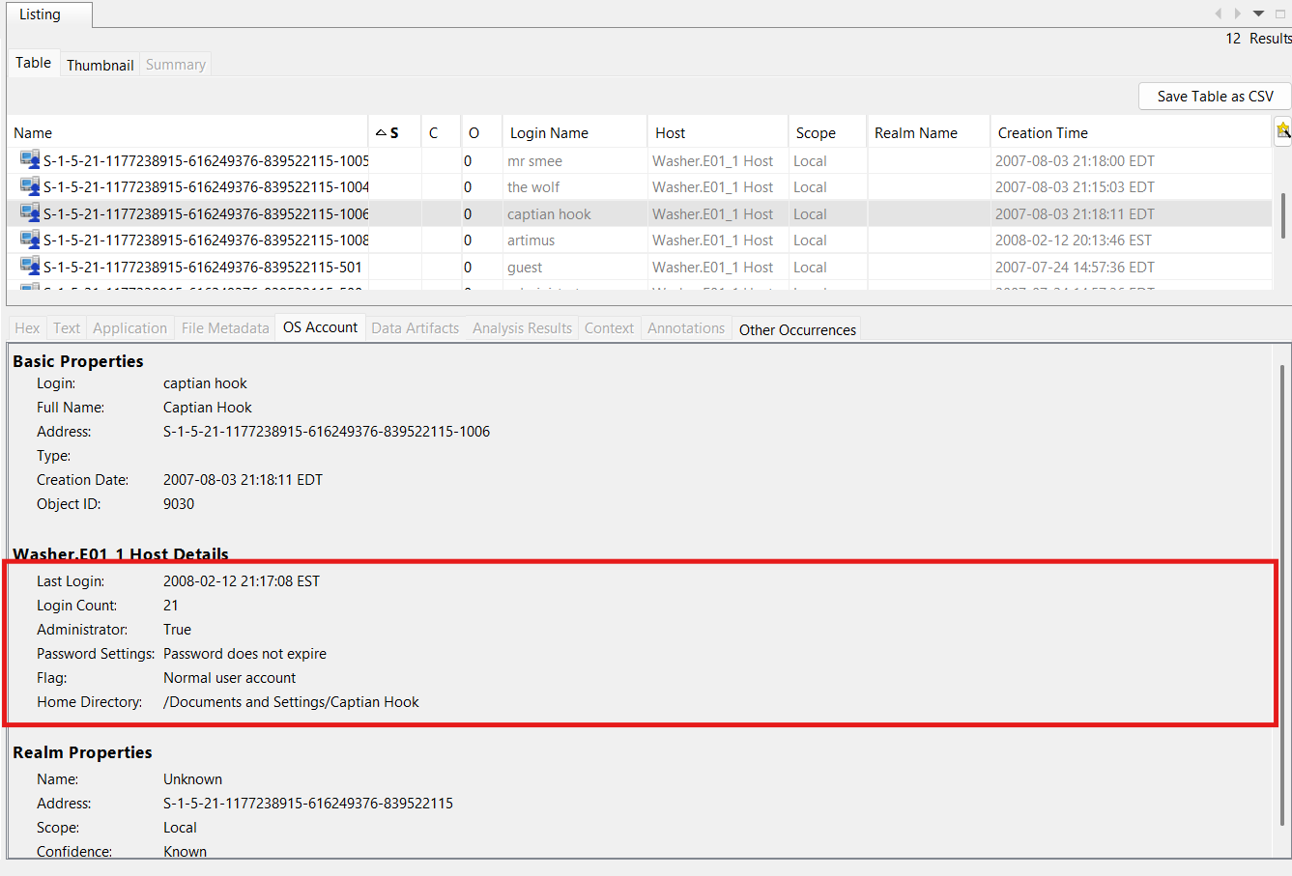

Figure 6 shows last login time

#### **3. User Activity**

* Recently accessed documents: Monkey-nerd.jpg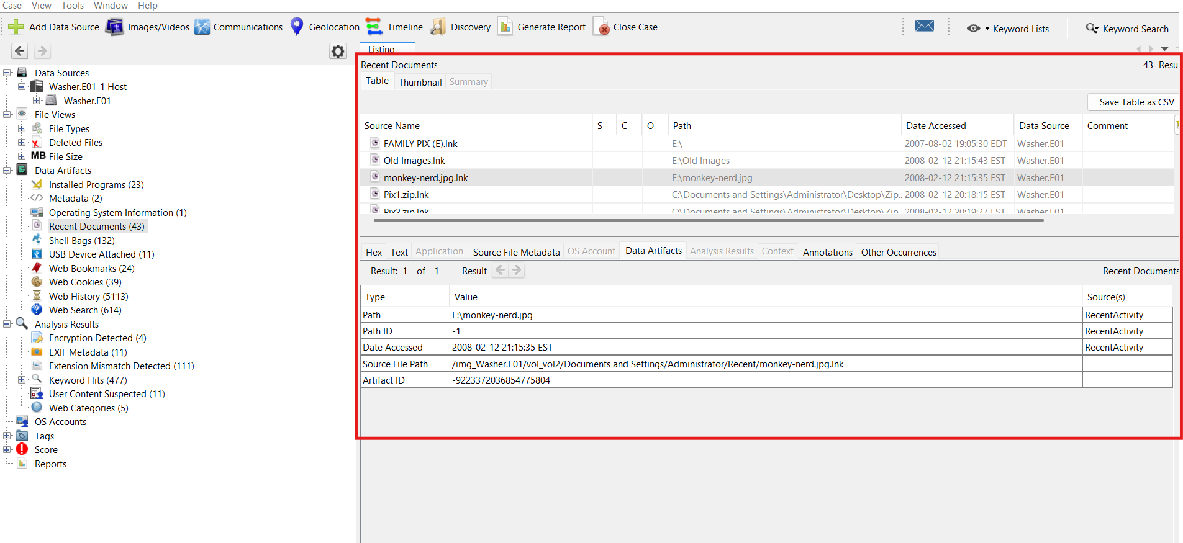

Figure 7 shows a recently accessed document titled Monkey-nerd

* Download folder contents of interest: How to steal credit numbers .doc

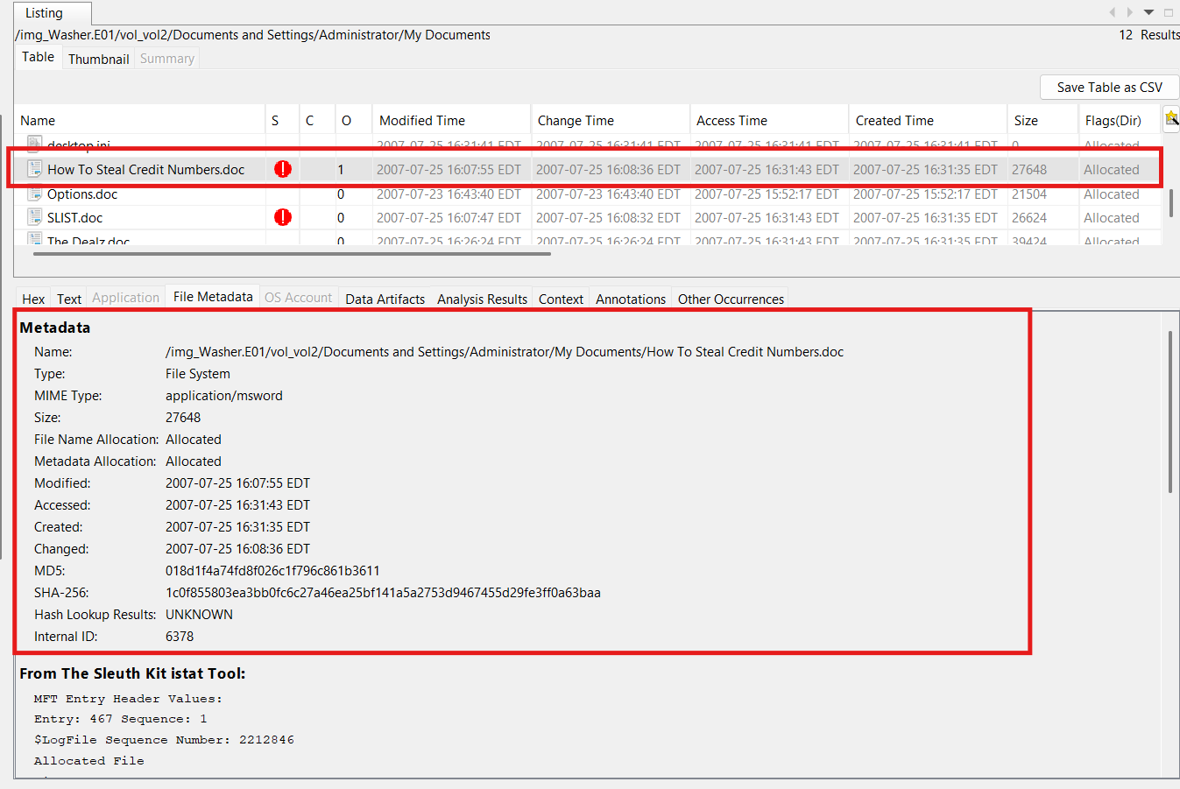

Figure 8 shows a file labeled how to steal credit numbers.doc

* Encrypted or password-protected files located at: All state credit agency.pdf I wasn’t able to find a password in the files for it. I attempted the password M3th1sR1sky (found later) but it didn’t unlock.

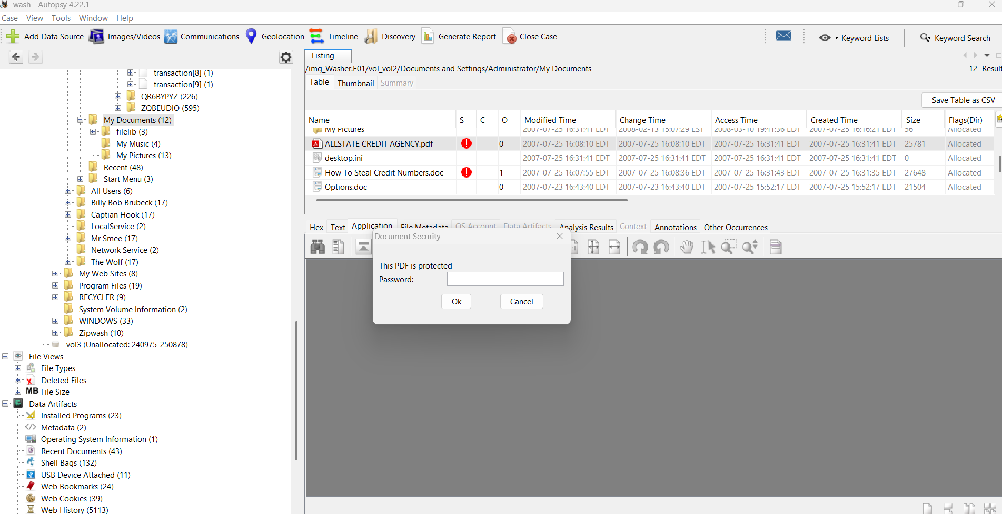

Figure 9 shows an encrypted file labeled all state credit agency

#### **4. USB / External Devices**

* USB device connected: SDCZ2 Cruzer Mini Flash Drive (thin)
* Make/Model/Serial Number: San Disk Corp, SDCZ2 Cruzer Mini Flash Drive (thin), 20041101101b4bc0091b
* Date and time last connected: 2008-02-13 00:22:08 EST

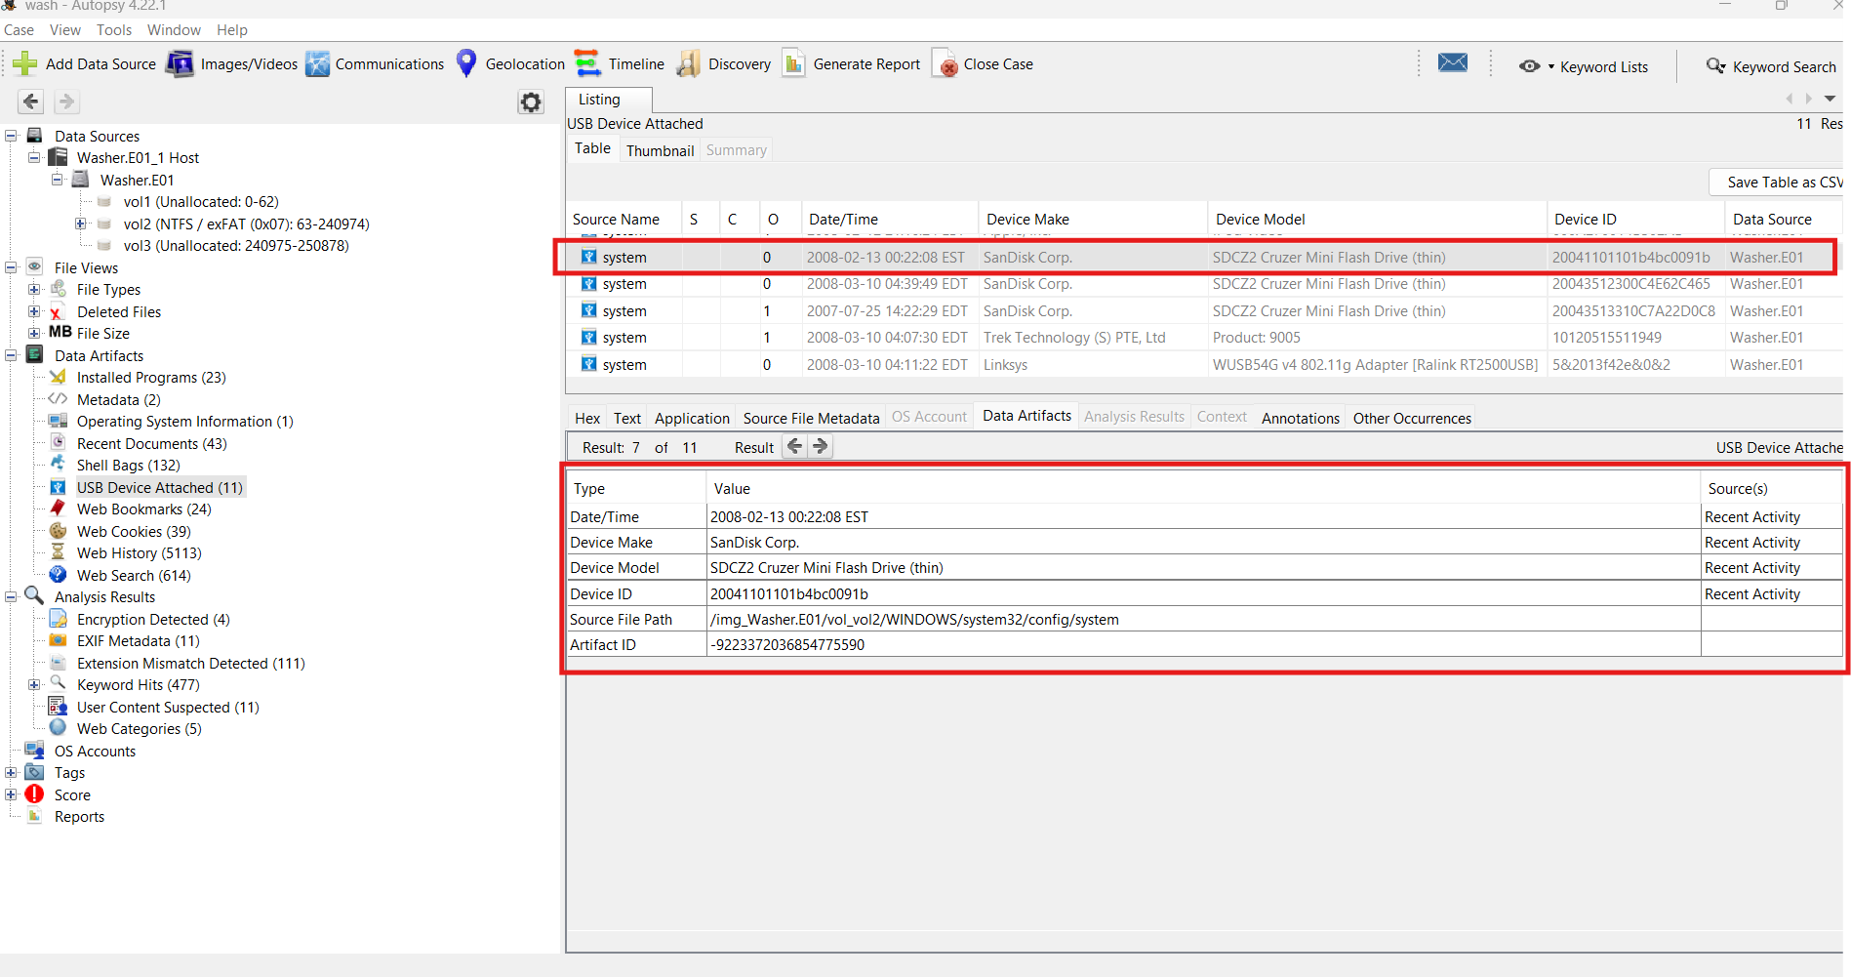

Figure 10 shows a usb device that was in the machine

#### **5. Internet Activity**

* At least three visited websites: edge.ru4.com/, aimtoday.aim.com/today/, 2o7.net/. All either defunct or dangerous to go to.

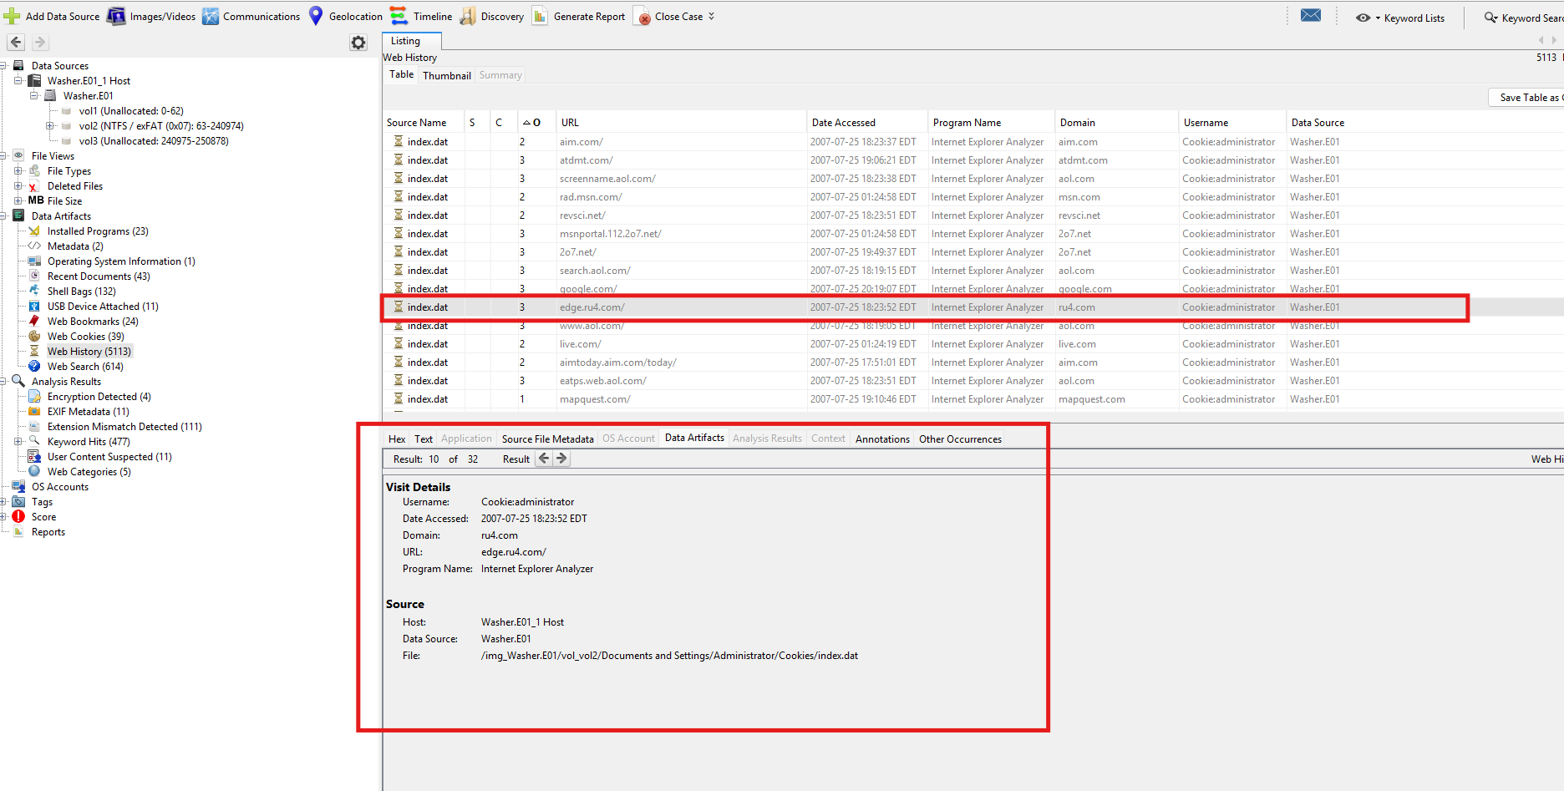

Figure 11 shows edge.ru4.com/ in the browser history

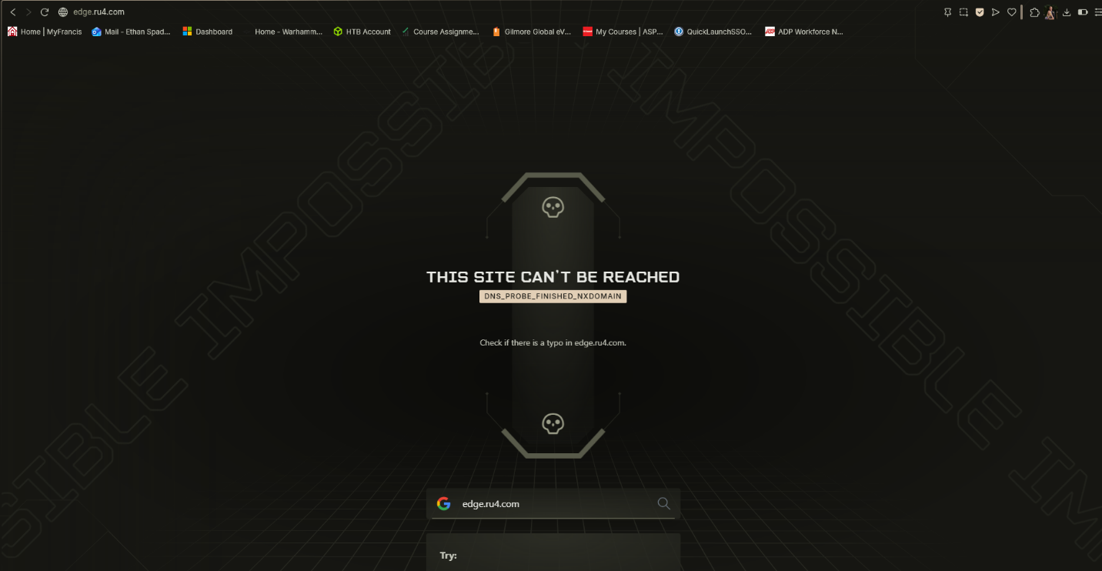

Figure 12 shows the downed site for edge.ru4.com/

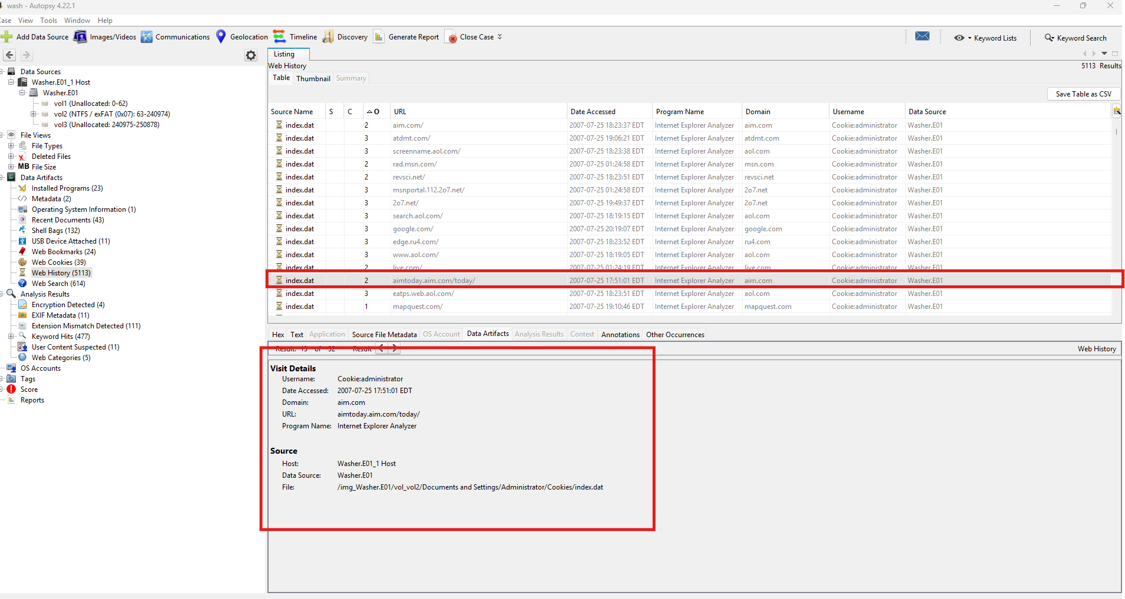

Figure 13 shows aimtoday.aim.com/today/, in the browser history

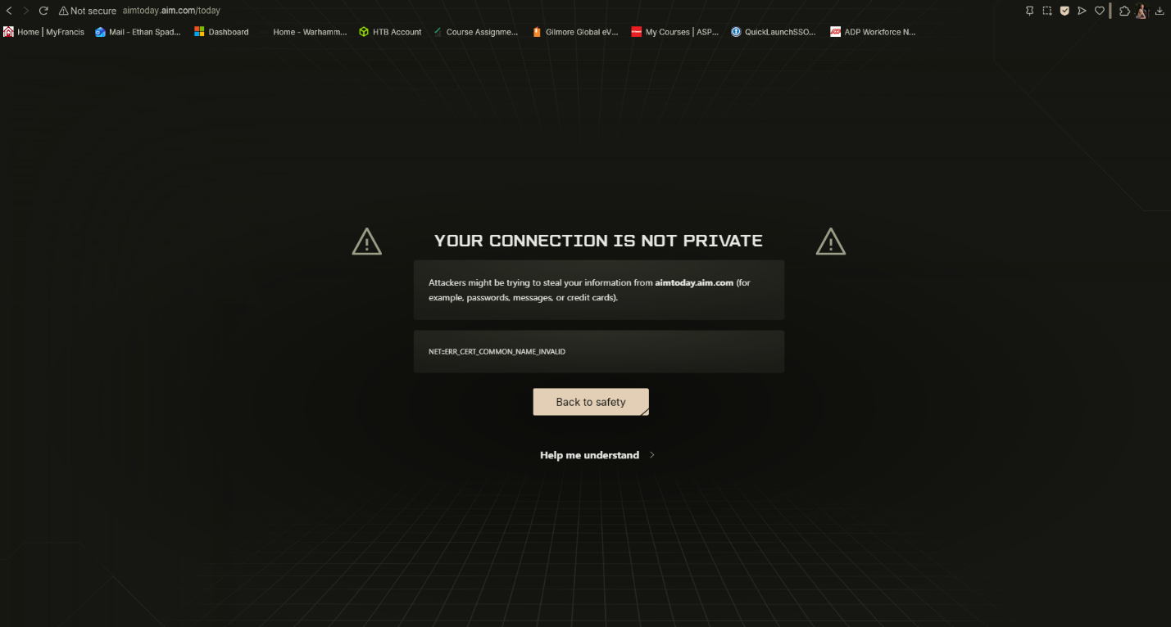

Figure 14 shows a warning received from visiting aimtoday.aim.com/today/,

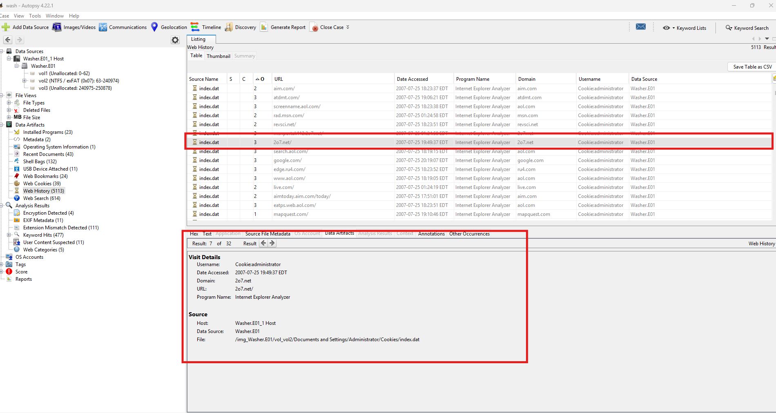

Figure 15 shows 2o7.net/ in the browser history

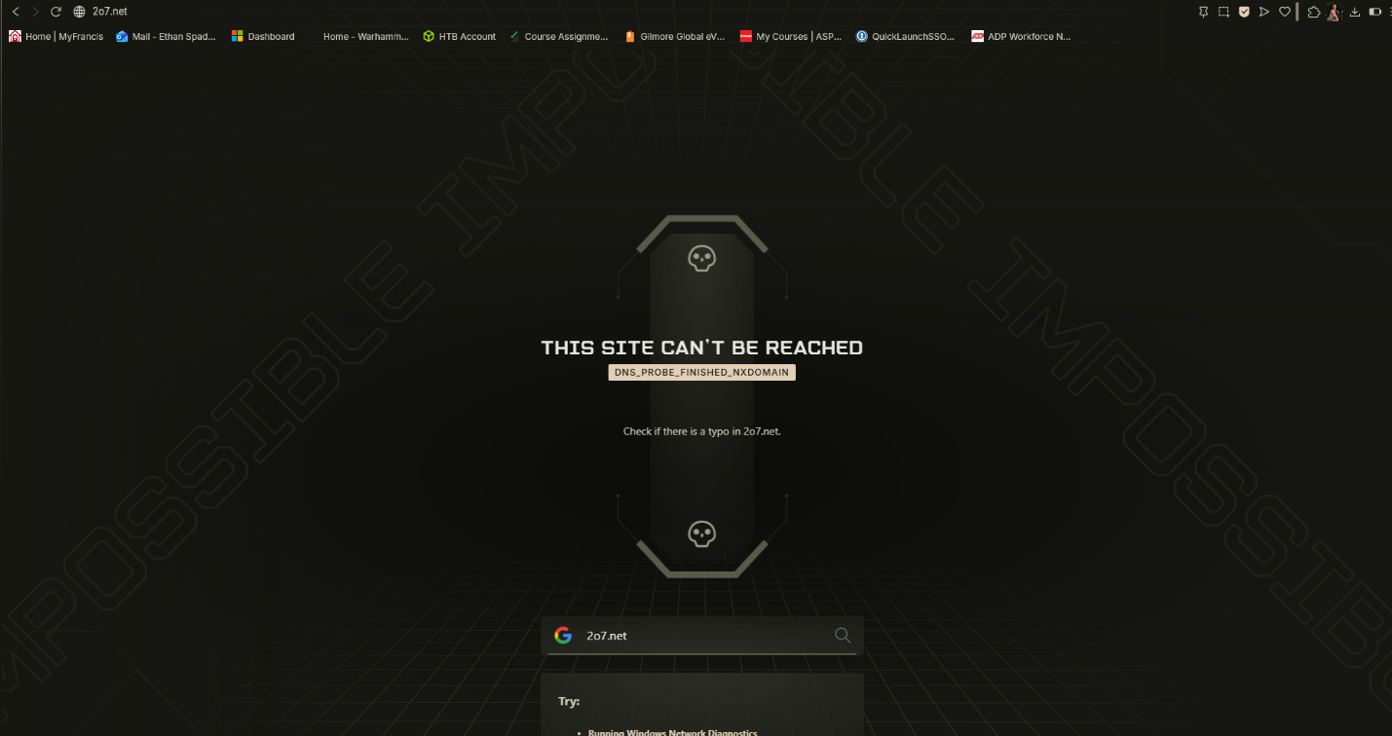

Figure 16 shows the downed site for 2o7.net/

* Suspicious search queries: Switching identities

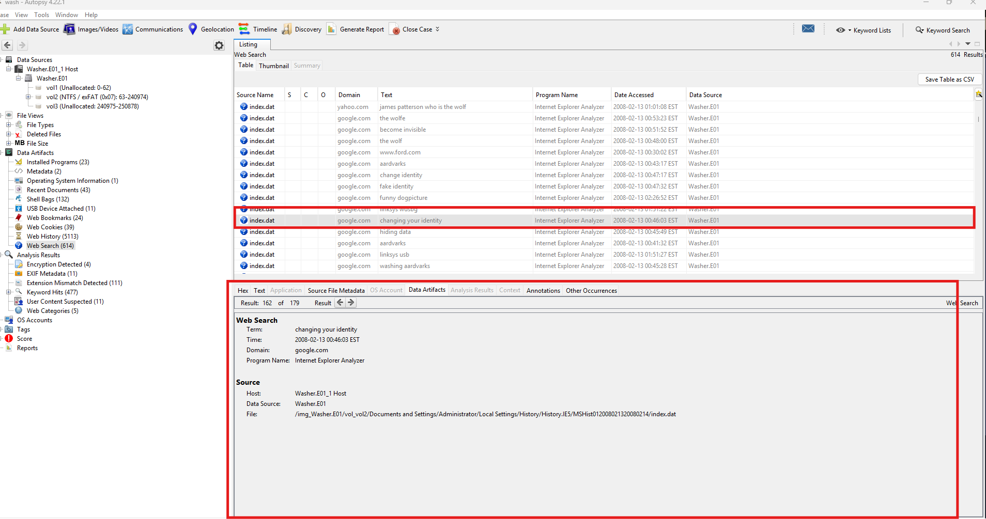

Figure 17 shows the user googling how to change your identity

* Any indicators of criminal or illicit activity online: Searches for switching identities, fake ID’s and other such illicit searches

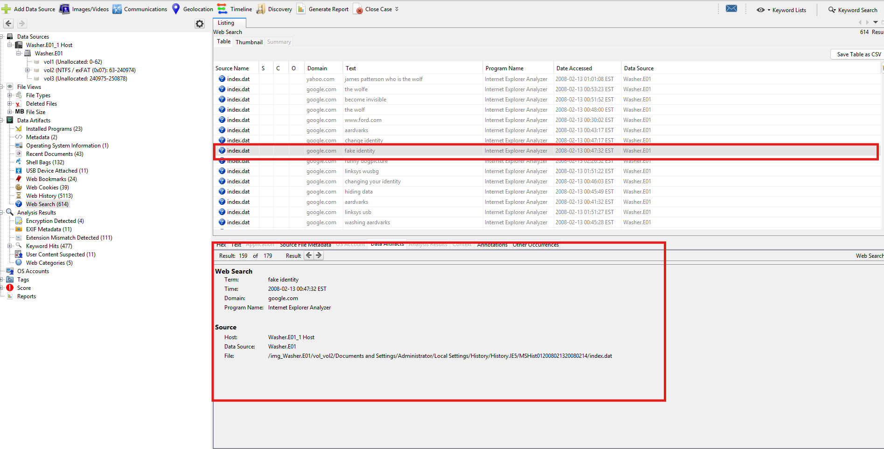

Figure 18 shows the user searching for fake identities

#### **6. Email and Communication**

* Email clients or webmail used: Comcast.net

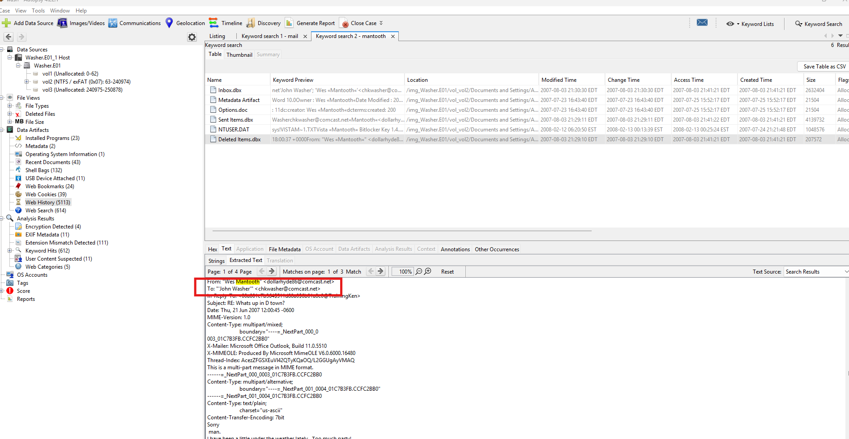

Figure 19 shows John Washer using comcast.net

* Email addresses located: chkwasher@comcast.net



Figure 20 shows John Washer's email chkwasher@comcast.net

* Example email correspondence or attachment related to Mantooth:

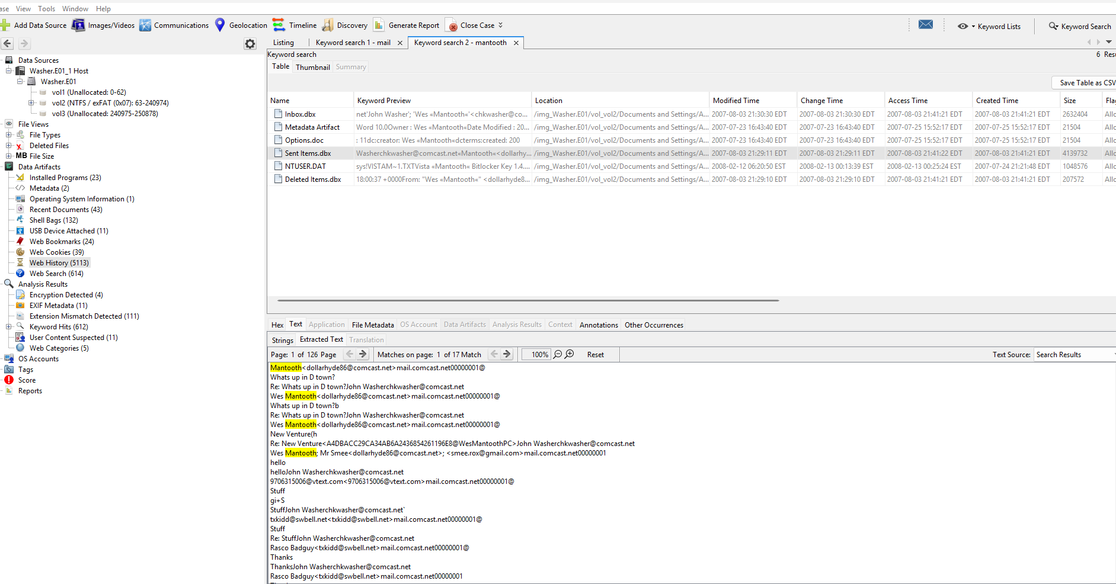

Figure 21 shows email conversation titles between John Washer and Wes Mantooth

* Indicators of collaboration or coordination between Washer and Mantooth:

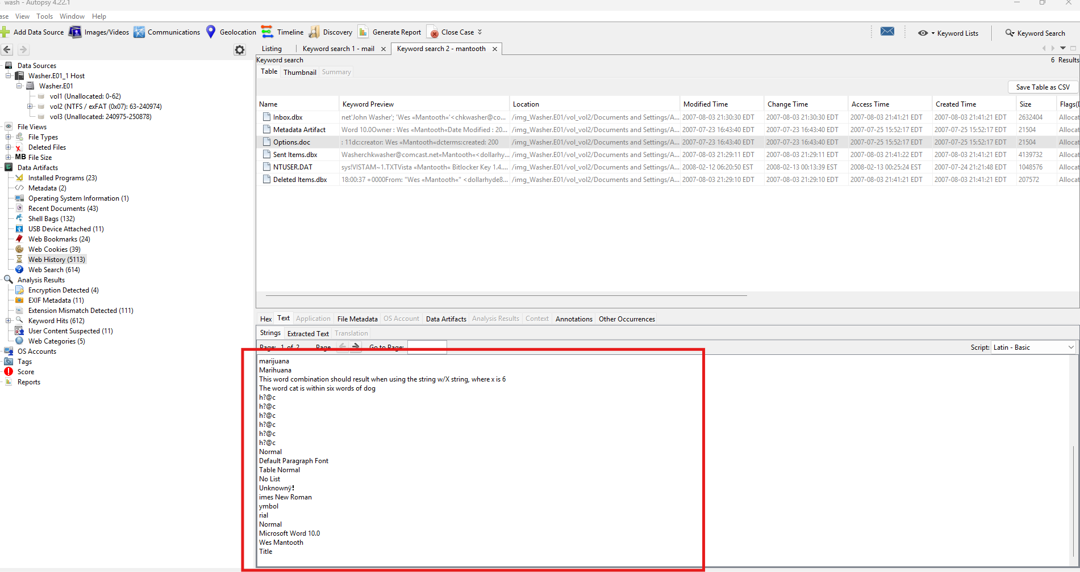

Figure 22 shows a hash code sent to washer from Mantooth. With words used such as Marijuana and killer, it can't mean anything good

#### **7. Images, Media, and Documents**

* Notable images recovered: Furry artwork, and a fascination with google earth

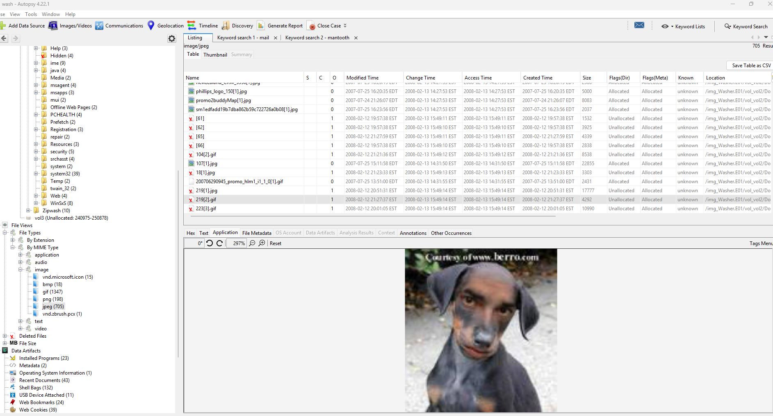

Figure 23 shows only what can be described as John Washer's Zoomorphphillia fetish. I had to see so you do too.

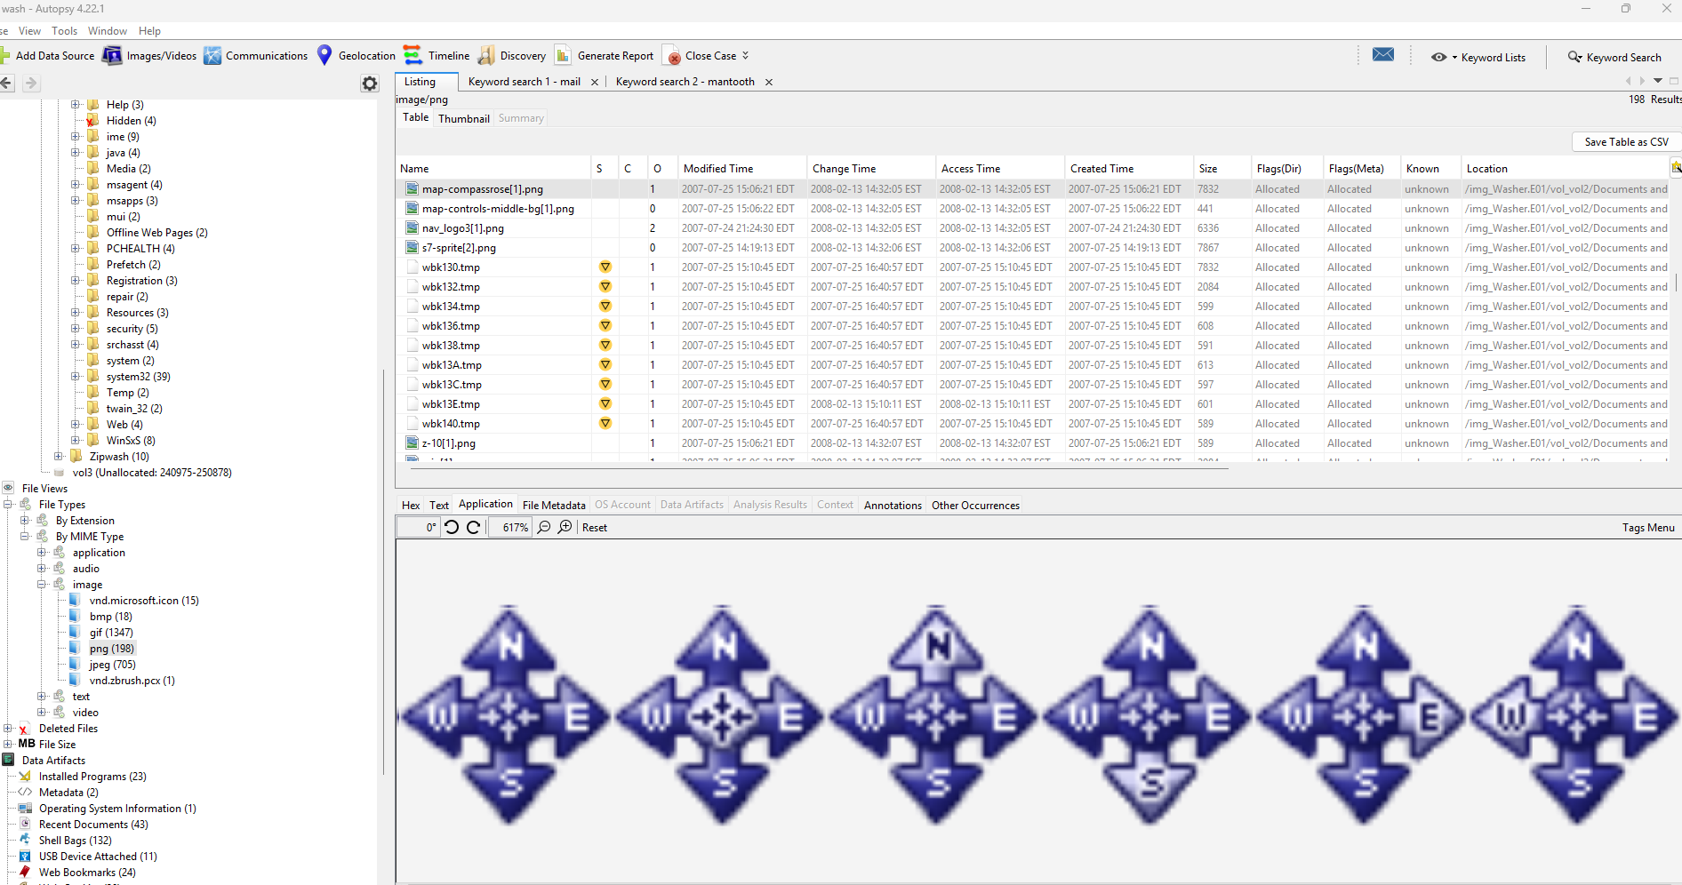

Figure 24 shows controls for google earth

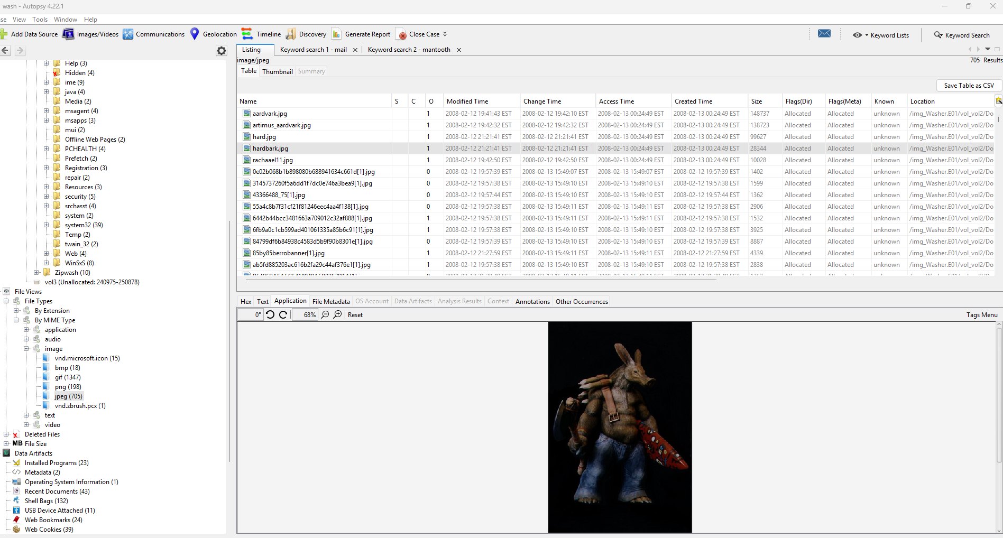

Figure 25 shows more furry art work this time of an Aardvark man. John Washer deserves the death sentence

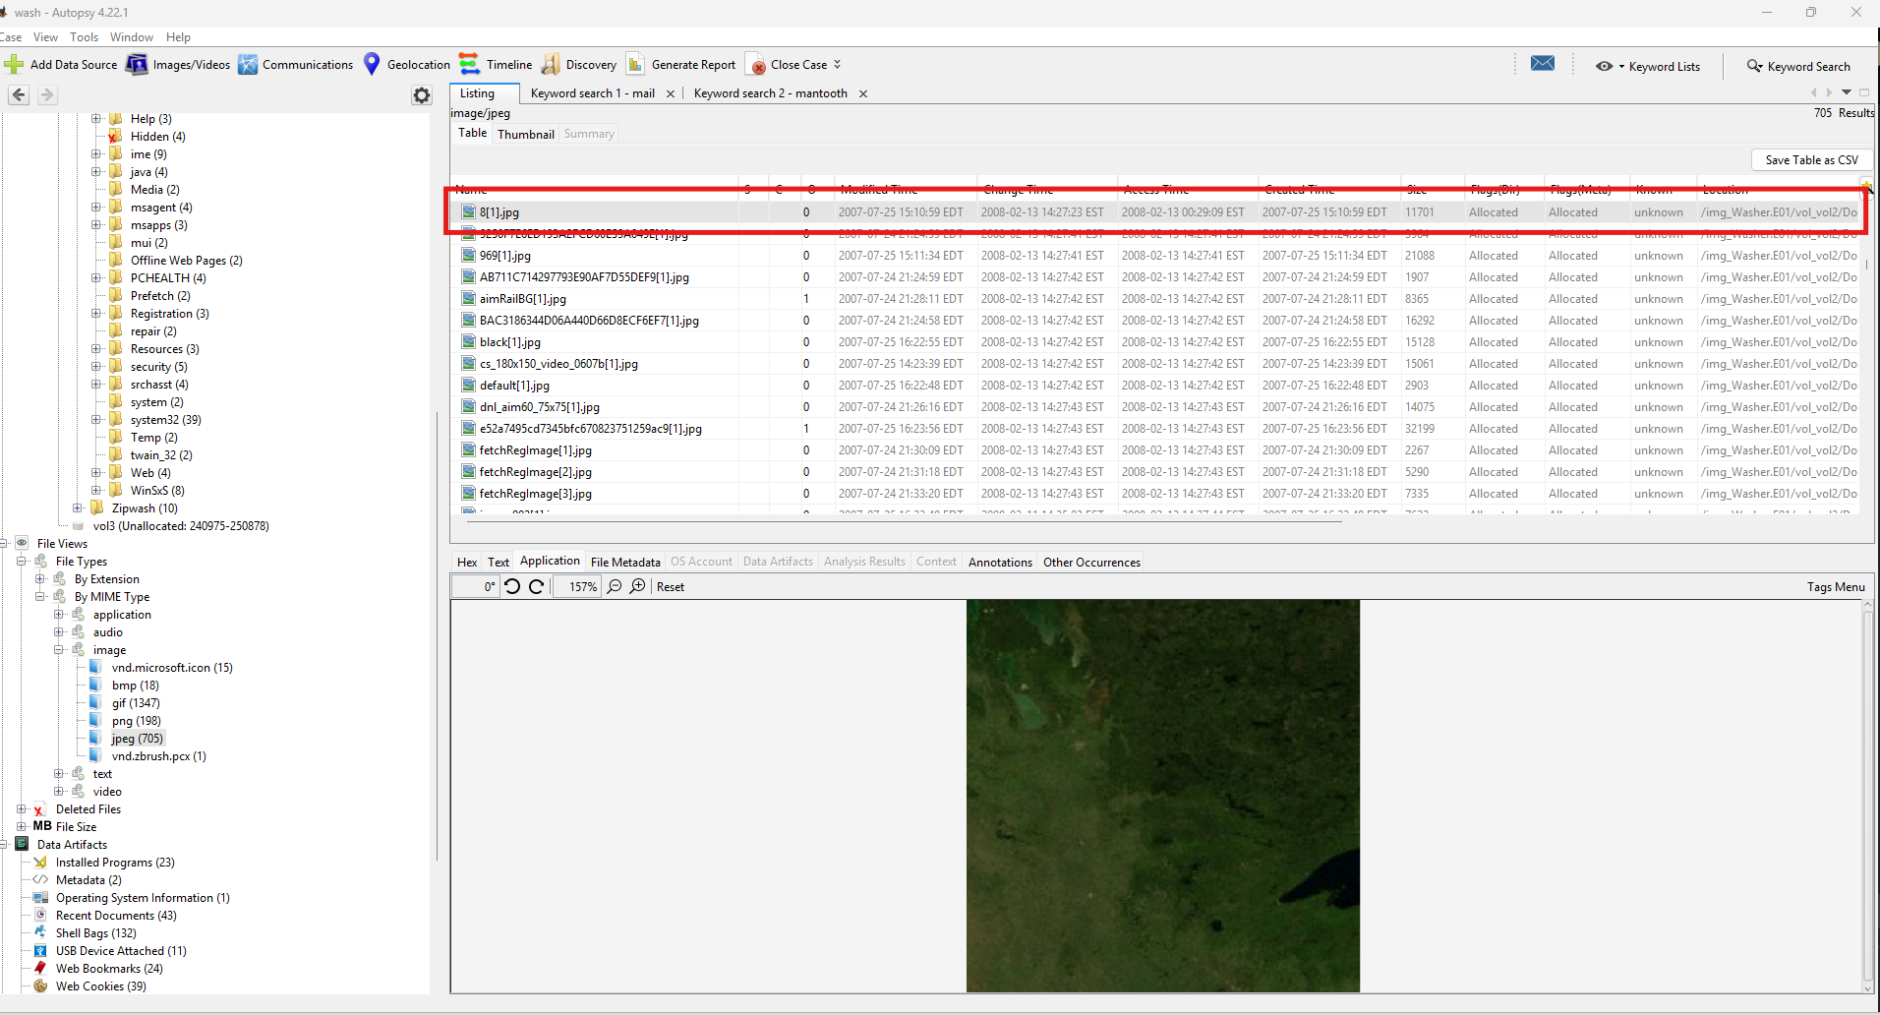

Figure 26 shows photos from what appear to be photos of google earth

#### **8. Software and Applications**

* Installed programs: IE5BAKEX, Outlookexpress

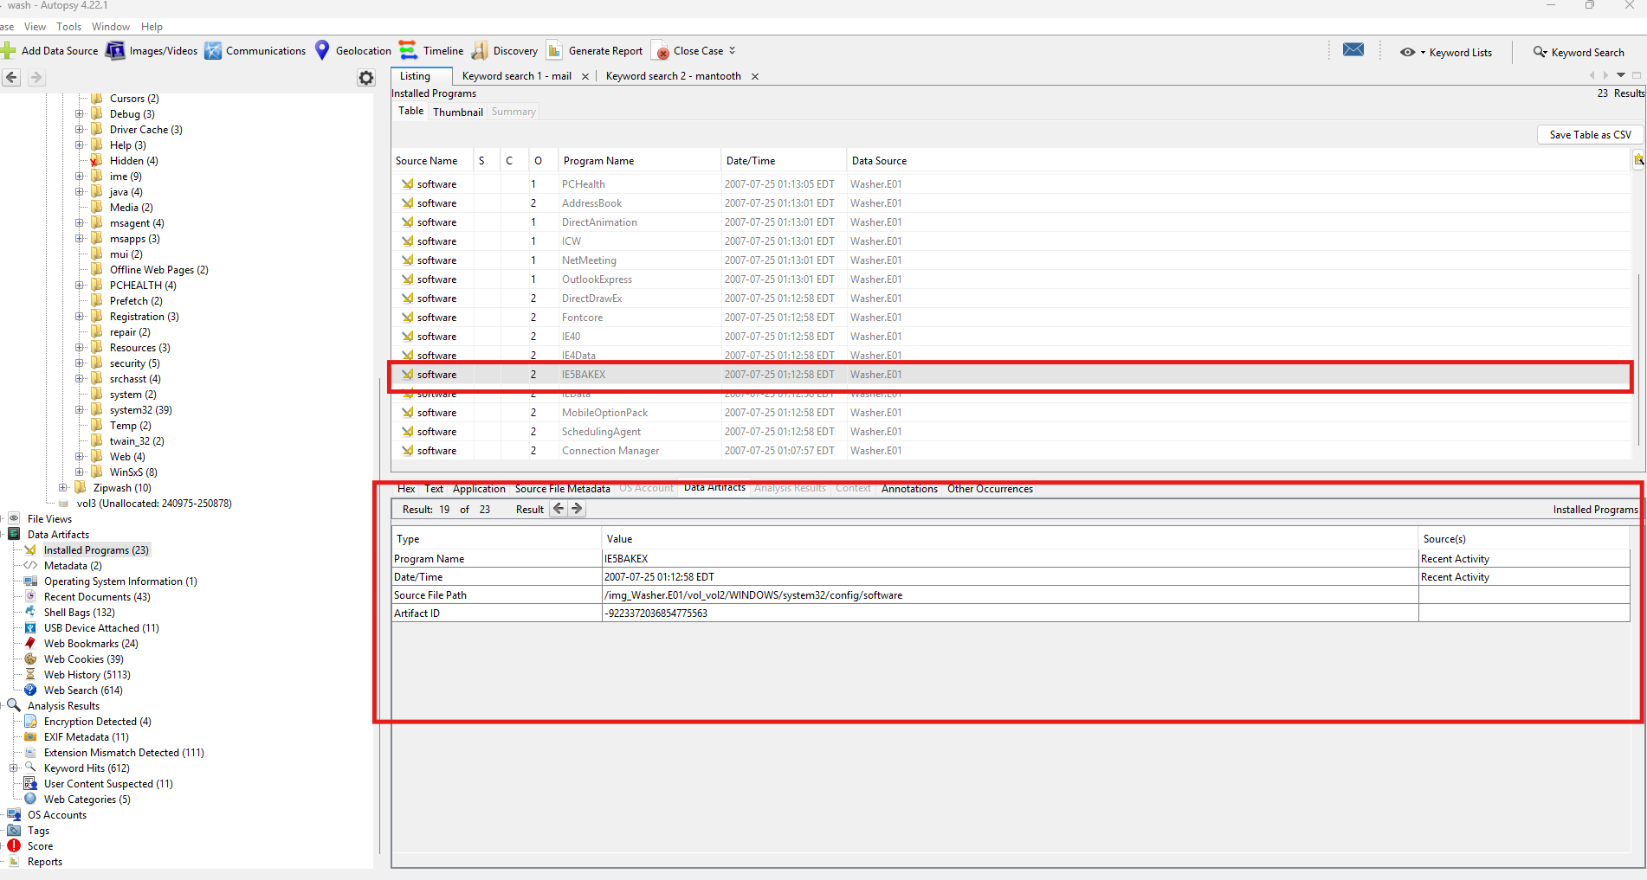

Figure 27 shows a program labeled IE5BAKEX on the users device. This may indicate legacy browser data or backup activity relevant to user web usage.

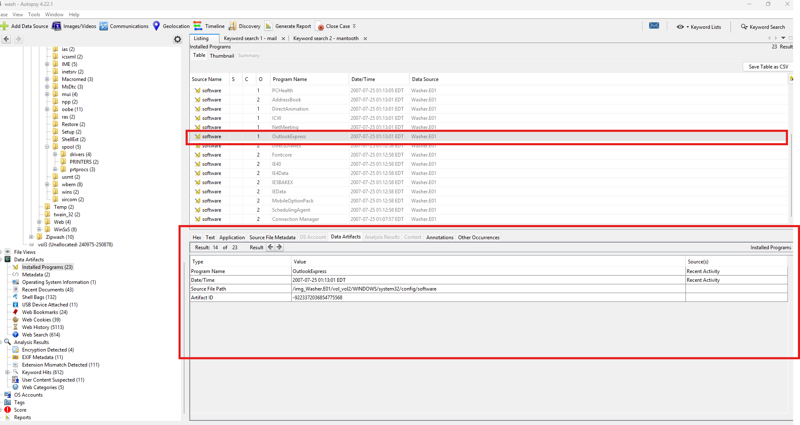

Figure 28 shows outlookexpress located on the users device

#### **9. Deleted or Hidden Files**

* Recovered file names and paths: South Pinwheel – Alert KFF.jp, Andromeda Galaxy M31 – Alert KFF.jpg

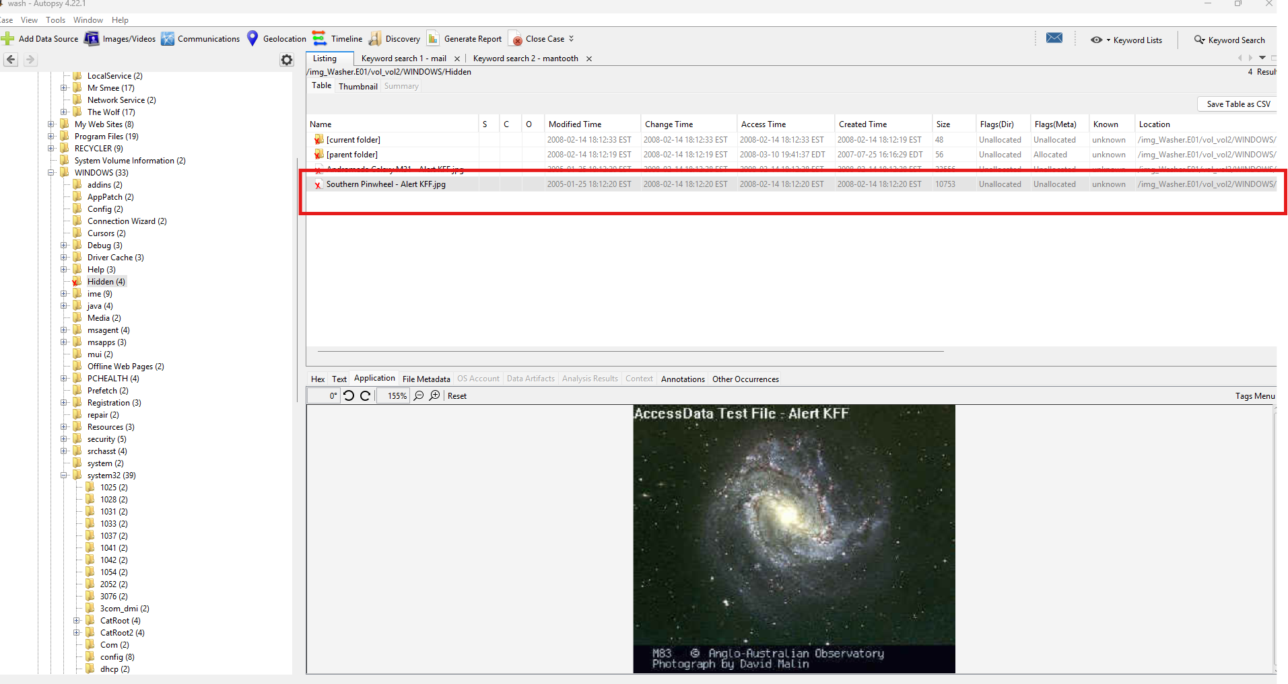

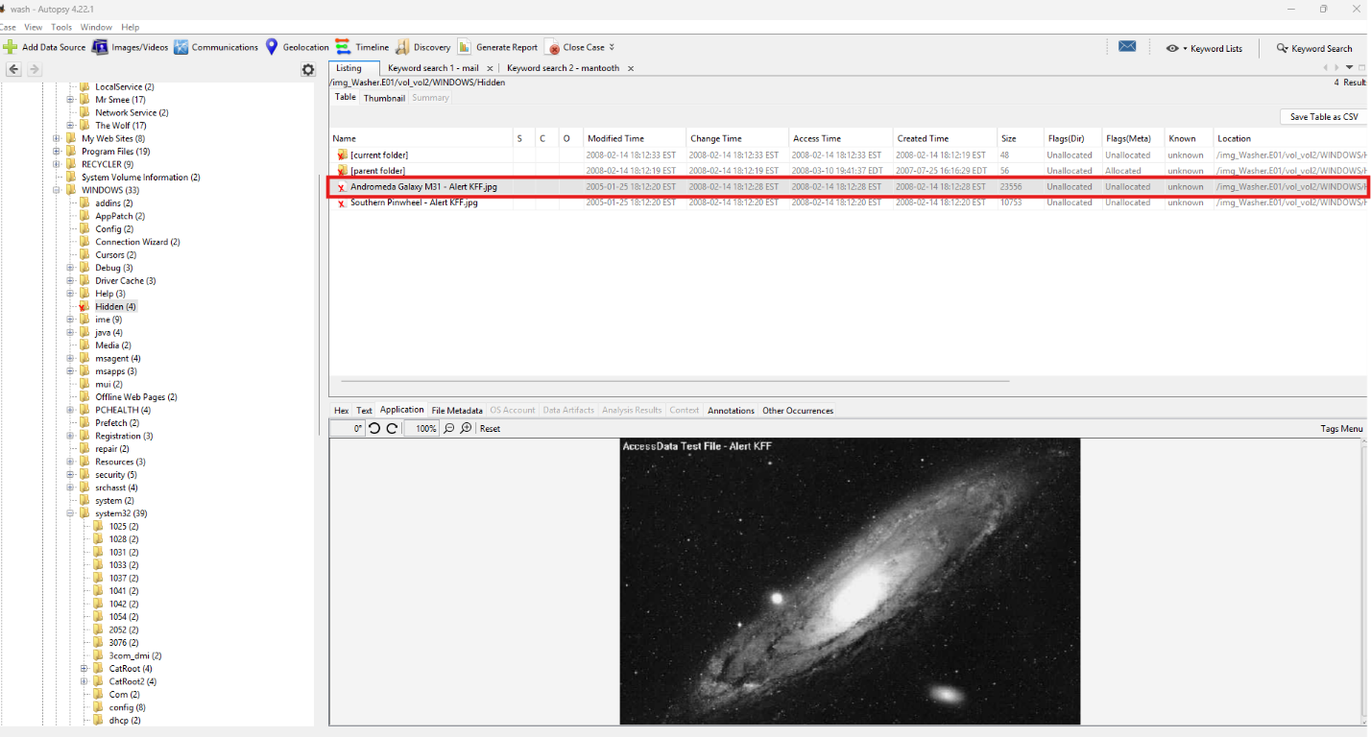

#### **10. Timeline of Activity**

# **Forensic Activity Timeline (Based on Provided Artifacts)**

### **July 23, 2007 — Email Activity**

* Sent Items.dbx was modified at **16:43:40**.  
  This indicates the user was actively sending email around this time, establishing a baseline of communication activity in mid-2007.

### **August 3, 2007 — Email Inbox and Deletions**

* At **21:29:10**, Deleted Items.dbx was modified, suggesting emails were deleted.
* One minute later, at **21:30:30**, Inbox.dbx was modified.  
  This sequence implies the user was receiving emails and immediately deleting some of them, potentially to hide communications.  
  Names appearing in keyword searches (e.g., Mantooth) may link these events to ongoing correspondence.

### **August 24, 2007 — User Profile Change**

* NTUSER.DAT was last written at **01:24:28**.  
  This reflects a change in the user profile—possibly due to login/logout activity or system configuration adjustments.

### **September 2007 (Undated) — Image Viewing**

* The image **07-09-very-old-man.jpg** was opened at least once, as shown by .lnk files and shellbag artifacts.
* Additional images, including **chinamanbeard.jpg**, also show multiple .lnk artifacts, indicating repeated viewing.  
  These may correlate with shared or exchanged images and potential links to Mantooth.

### **2007–Unknown Dates — Other Image Access**

* Multiple .lnk shortcuts indicate the user frequently opened folders containing these images.  
  This suggests ongoing engagement with the image sets throughout mid–late 2007.

### **February 12, 2008 — Last Known Login**

* At **21:17:08**, user account **“Captain hook”** logged in successfully.  
  This is the last recorded successful login before the system acquisition.

### **February 13, 2008 — USB Device Activity**

* At **00:22:08**, a **SanDisk Cruzer Mini USB** device was connected.  
  The timing (within ~3 hours of the final login) strongly suggests possible data transfer, exfiltration, or file movement.

**Suspicious or Incriminating Files**

* **Mantooth Bitlocker Key 1.4.txt** appears in registry and shellbags.  
  This implies the user interacted with the file even though it may not exist on disk anymore, and it suggests knowledge of or collaboration with Mantooth.
* **How to steal credit numbers.doc** found in Downloads.  
  This indicates possible research or intent tied to credit fraud.
* **All state credit agency.pdf** is present and encrypted.  
  The encryption suggests the user intentionally protected sensitive or potentially incriminating information.

### **Web Browsing Activity**

* Domains accessed include:
  + edge.ru4.com/
  + aimtoday.aim.com
  + 2o7.net

These reflect general browsing behavior. Some domains are associated with ad-tracking; others may indicate communication portals or suspicious content.

### **Email Account Activity**

* DBX email stores show active use of the account **chkwasher@comcast.net**, demonstrating the user was actively engaged in email communication—possibly tied to Mantooth based on keyword hits.

# **Condensed Chronological Overview**

1. **Mid-2007:** User is actively sending and receiving emails (Sent Items/Inboxes modified).
2. **Late July–August 2007:** Email deletions occur rapidly after receipt.
3. **August 2007:** User profile/settings updated (NTUSER.DAT).
4. **September 2007:** User views multiple images, some appearing repeatedly in artifacts.
5. **Late 2007–Early 2008:** Undated but ongoing image access, suspicious file artifacts, and web browsing.
6. **Feb 12, 2008:** Final successful login by “Captain hook.”
7. **Feb 13, 2008:** USB drive connected possible final data movement.
8. Evidence of credit related documents, encrypted files, and references to Mantooth-linked artifacts.

#### **11. Correlation to Mantooth**

* Shared file names or directory structures:

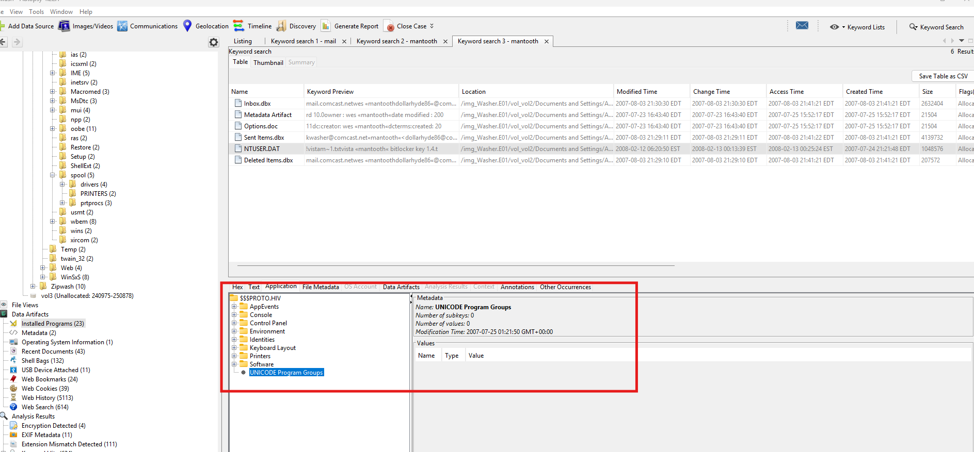

Figure 29 shows a UNICODE program Groups sent by Wes Mantooth

* Matching or similar passwords, usernames, or email handles:

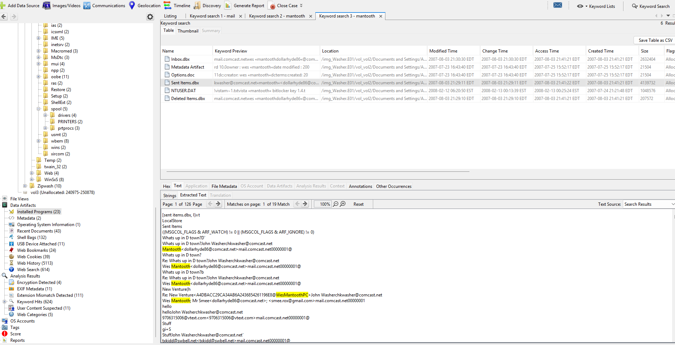

Figure 30 Shows Wes Mantooth along with the name Mr. Smee

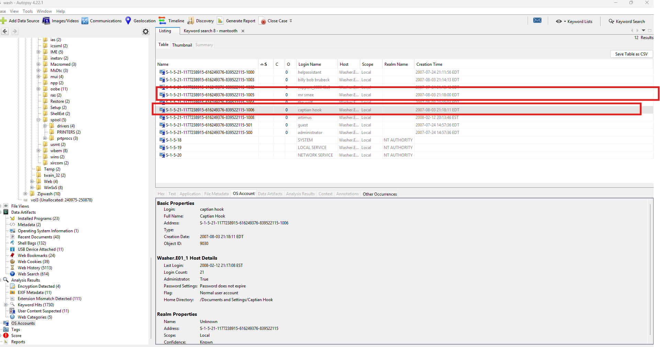

Figure 31 AShows the user accounts Mr. Smee and Captain Hook

* Common software usage or network connections:

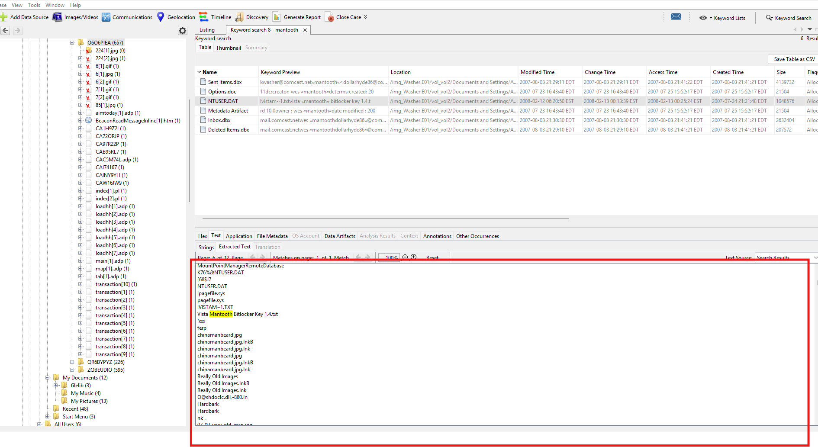

Figure 32 shows A bitlocker key used by Wes Mantooth for the previously seen NTUSER.DAT software

* Artifacts referencing Mantooth directly (messages, documents, images):

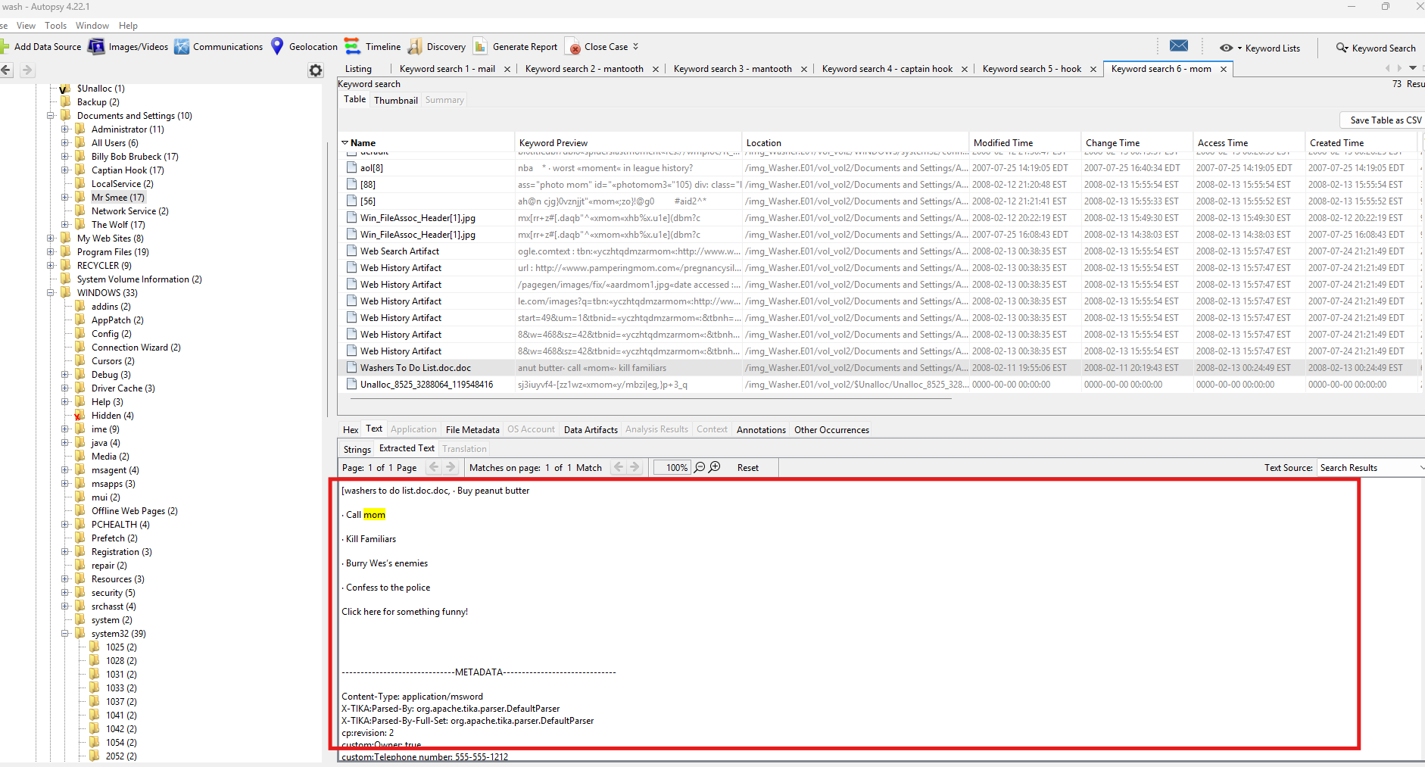

Figure 33 Shows a To Do list found on John's Device. Specifically the entries, Call mom, Kill Familiars, Burry Wes's enemies, confess to the police

#### **12. Indicators of Criminal Activity**

* Summary of potential offenses (e.g., data theft, drug-related material, malware creation):

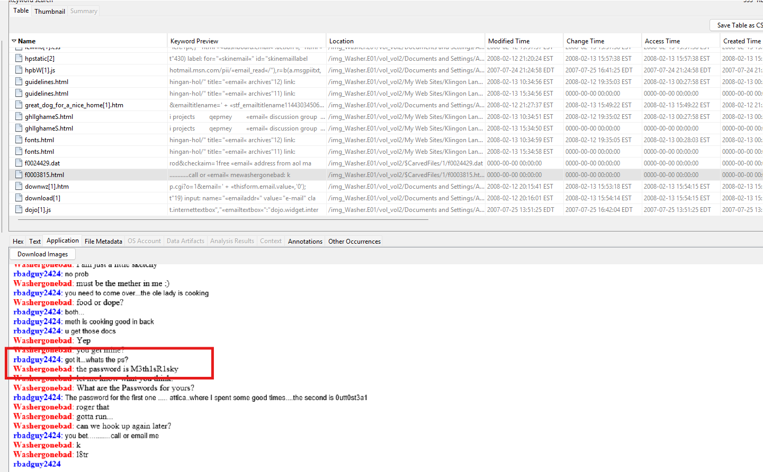

Figure 34 shows a password found in a conversation between Washergonebad (John Washer) and rbadguy2424 (Roscoe Badguy)

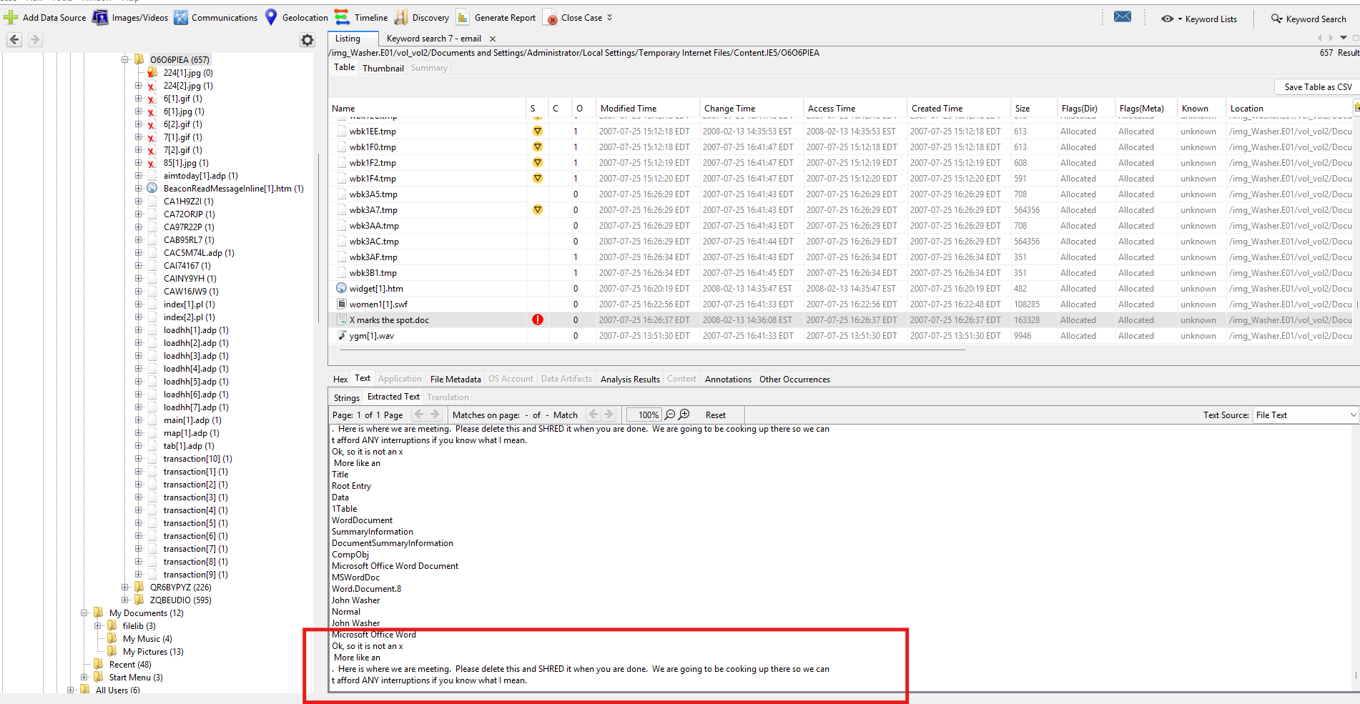

Figure 35 John discussing meeting to "do cooking" with most likely Wes and/ or Roscoe

### **5. Analysis Summary**

The forensic analysis of Washer.E01 shows sustained user activity tied directly to email communication, image viewing, internet browsing, and interaction with suspicious documents from mid-2007 through early 2008. Email database files (Inbox, Sent Items, Deleted Items) demonstrate consistent communication patterns, including rapid deletion of messages, behavior suggestive of concealment. Shellbags and shortcut artifacts confirm repeated access to specific images and directories, while registry modification of NTUSER.DAT reflects active user profile changes. The discovery of How to steal credit numbers.doc, the encrypted All state credit agency.pdf, and browsing history related to identity alteration point toward potential credit fraud related intent or preparation.

Across the system, multiple artifacts demonstrate a clear operational link between John Washer and Wes Mantooth. References to “Mantooth Bitlocker Key 1.4.txt,” email subject lines involving Mantooth, and encryption-related data suggest that Washer handled or shared materials associated with Mantooth’s activities. The final login on February 12, 2008 and subsequent USB connection on February 13 further indicate likely data movement shortly before the device was acquired. Taken together, the activity timeline, communication evidence, encrypted files, and suspicious documents strongly support the conclusion that Washer engaged in coordinated and potentially illicit digital activity parallel to that found on the Mantooth system.

### **6. Conclusion**

The examination of the Washer.E01 disk image provides substantial evidence connecting John Washer to Wes Mantooth through shared file references, email communication, and the handling of encryption-related materials. The presence of suspicious documents, encrypted files, rapid email deletions, identity-related searches, and late-stage USB activity all indicate purposeful data concealment and potential involvement in coordinated illicit behavior. When considered alongside corresponding artifacts found in the Mantooth investigation, the combined evidence supports a clear pattern of collaboration between the two individuals.